Its a prototype for an IoT based Overload or suspension Fault detection.

What is Ride Height?

**Ride height**  is the amount of space between the base of an automobile [tire](https://en.wikipedia.org/wiki/Tire" \o "Tire) and the lowest point; or, more properly, to the shortest distance between a flat, level surface, and the lowest part of a vehicle other than those parts designed to contact the ground. Ground clearance is measured with standard vehicle equipment, and for cars, is usually given with no cargo or passengers.

Ride height may dramatically impact the alignment, the directional stability, stopping distances and steering. It’s also a key factor in the durability of most suspension components, including shocks, struts and tires.

Concept:

Using several test and research papers where ride height parameters were evaluated, following was observed.

The average maximum height change for the unladen tests was -57 mm with a range of ±9mm. The results indicate that the change in height decreased slightly as braking speeds increased. For the laden test the maximum height change was 62mm which was similar in value to the low-speed unladen tests.

Test Results:

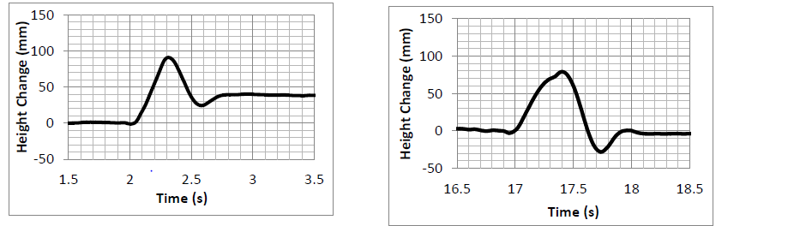

The change in height at the rear of the vehicle was significantly less than that of the unladen vehicle when braking from a similar speed. This is thought to be due to a stiffening of the rear suspension system under load.

Project:

Load plays a significant role in Ride height reduction. Increase in load for static state results in reduced ride height.

Using Distance Sensors mounted on the base of the vehicle distance with ground is measured under No load.

This distance is caliberated and a maximum reduction in ride height as per chassis is decided upon. Once this is exceeded, a warning can be issued and vehicle operation can be shut down.

Uneven Ride height can also be a good indicator of fault in suspension.

Role of IOT in project:

IOT is used to store this data and also take intelligent decisions based on other parameters.

For overload a decision can be taken based upon distance to be travelled, terrain to be travelled, prior faults and past services.

For Suspension Fault Diagnostic data can be stored for later analysis as to why fault occurred under what conditions and its severity can be understood.

Towards Envisioned Product :

A more accurate and reliable sensor such as Eddy current sensors and optical sensor like LIDAR can be used for millimetre level precision.